Part A Plots:

Displacement:

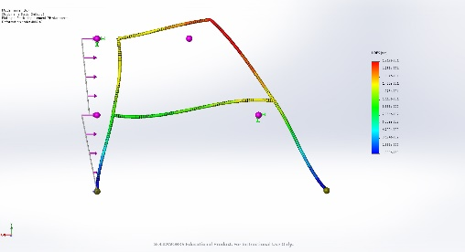

Moment: (Note: Moment is along where the force is, due to Solidworks autosave feature it did not capture the diagram lines.)

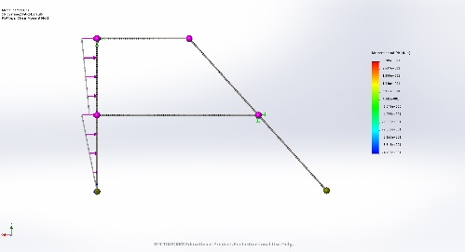

Stress:

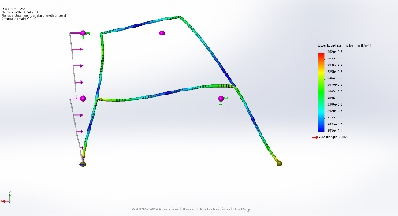

Stress Axial:

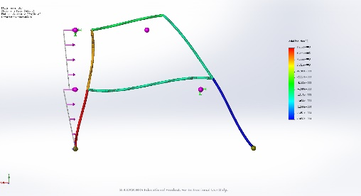

Part B Plots:

Displacement: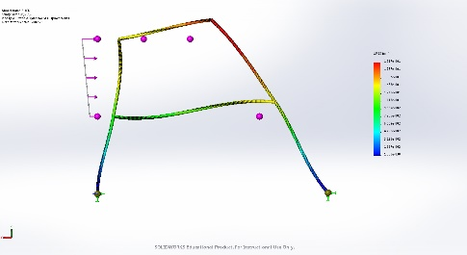

Moment: 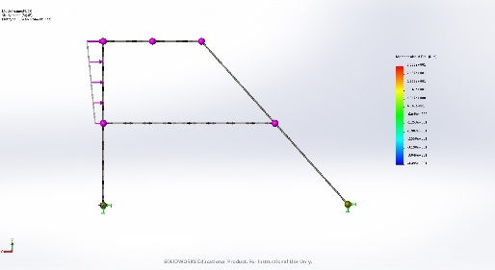

Stress: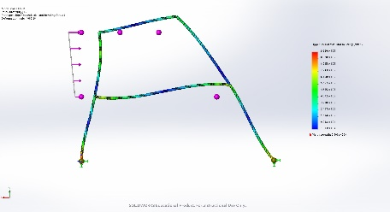

Axial Stress:

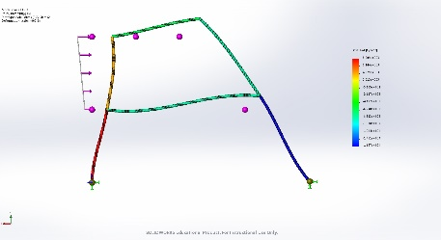

Discussion:

There is no difference in displacement between part A and B. No change in Axial Stress. No change in Stresses. No change in Moment as well. This is to be expected. Creating multiple elements within a single element really shouldn’t change the behavior of the beam, and it doesn’t.

Part C Plots:

Displacement:

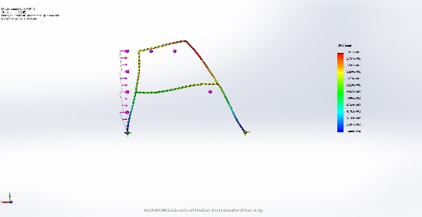

Moment:

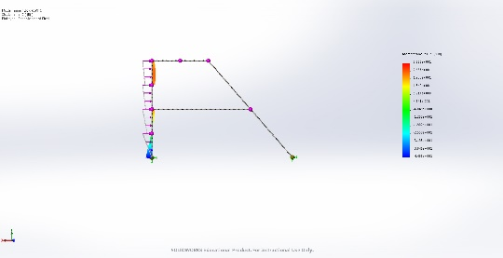

Stress:

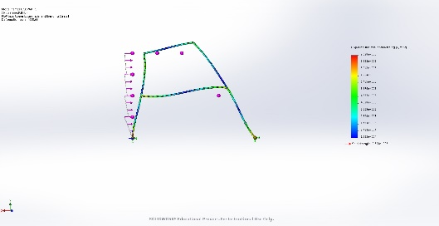

Axial:

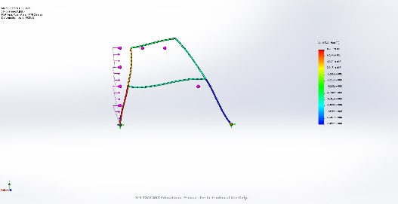

Discussion:

There is no change in any plot. This is to be expected. The connection should maintain the same integrity as a solid beam. Solidworks behaves as such.

Part D Plots:

Displacement:

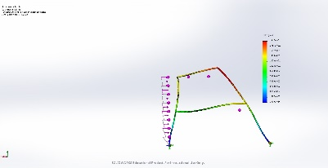

Moment:

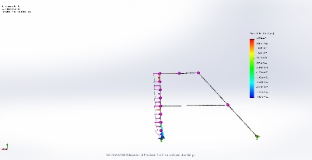

Stress:

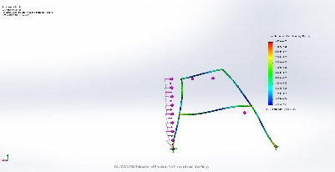

Axial:

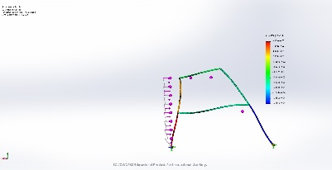

Discussion:

There is no differences again. Which is explained by the same reason as above. Solidworks makes it behave as one beam.

The most accurate would be the first one, since it is the easiest to set-up and all of them have the same values.